# Q1 to Q12 have only one correct answer. Choose the correct option to answer your question.

1. What is the most appropriate no. of clusters for the data points represented by the following dendrogram:

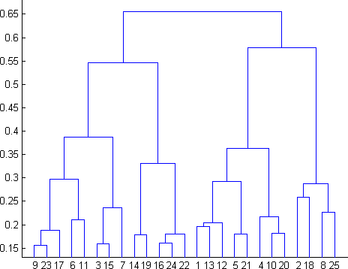

* 1. 2
  2. 4
  3. 6
  4. 8

1. In which of the following cases will K-Means clustering fail to give good results?
2. Data points with outliers
3. Data points with different densities
4. Data points with round shapes
5. Data points with non-convex shapes Options:
6. 1 and 2
7. 2 and 3
8. 2 and 4
9. 1, 2 and 4
10. The most important part of is selecting the variables on which clustering is based.
    1. interpreting and profiling clusters
    2. selecting a clustering procedure
    3. assessing the validity of clustering
    4. formulating the clustering problem
11. The most commonly used measure of similarity is the or its square.
    1. Euclidean distance
    2. city-block distance
    3. Chebyshev’s distance
    4. Manhattan distance
12. is a clustering procedure where all objects start out in one giant cluster. Clusters are formed by dividing this cluster into smaller and smaller clusters.
    1. Non-hierarchical clustering
    2. Divisive clustering
    3. Agglomerative clustering
    4. K-means clustering
13. Which of the following is required by K-means clustering?
    1. Defined distance metric
    2. Number of clusters
    3. Initial guess as to cluster centroids
    4. All answers are correct
14. The goal of clustering is to-
    1. Divide the data points into groups
    2. Classify the data point into different classes
    3. Predict the output values of input data points
    4. All of the above
15. Clustering is a-
    1. Supervised learning
    2. Unsupervised learning
    3. Reinforcement learning
    4. None
16. Which of the following clustering algorithms suffers from the problem of convergence at local optima?
    1. K- Means clustering
    2. Hierarchical clustering
    3. Diverse clustering
    4. All of the above
17. Which version of the clustering algorithm is most sensitive to outliers?
    1. K-means clustering algorithm
    2. K-modes clustering algorithm
    3. K-medians clustering algorithm
    4. None
18. Which of the following is a bad characteristic of a dataset for clustering analysis-
    1. Data points with outliers
    2. Data points with different densities
    3. Data points with non-convex shapes
    4. All of the above
19. For clustering, we do not require-
    1. Labeled data
    2. Unlabeled data
    3. Numerical data
    4. Categorical data

# Q13 to Q15 are subjective answers type questions, Answers them in their own words briefly.

1. How is cluster analysis calculated?

Answer: The cluster analysis is calculated as the sum of squared distances between data points and the centers of the clusters they belong to.

1. How is cluster quality measured?

Answer: To measure the quality of a clustering, we can use the average silhouette coefficient value of all objects in the data set.

1. What is cluster analysis and its types?

Answer: Cluster Analysis is the process to find similar groups of objects in order to form clusters. It is an unsupervised machine learning-based algorithm that acts on unlabeled data. A group of data points would comprise together to form a cluster in which all the objects would belong to the same group.

The clustering methods can be classified into the following categories:

1. Partitioning Method.
2. Hierarchical Method.
3. Density-based Method.
4. Grid-Based Method.
5. Model-Based Method.
6. Constraint-based Method.